|  |  |  |
| --- | --- | --- |
| **Title** | **Actual result** | **Expected Result** |
| **Under 30 mins filter filter shows restaurants with exactly 30 min** | **Restaurants with a 30-minute delivery time appear in the Under 30 Min filter results, though only times below 30 minutes should be included.** | **Filter should only include times strictly below 30 minutes.** |

|  |  |  |  |  |  |
| --- | --- | --- | --- | --- | --- |
| **Version** | **Device** | **OS Version** | **Network** | **Severity** | **Priority** |
| **12.18.0** | **Samsung Galaxay A22** | **Android 13** | **WIFI** | **Medium** | **High** |

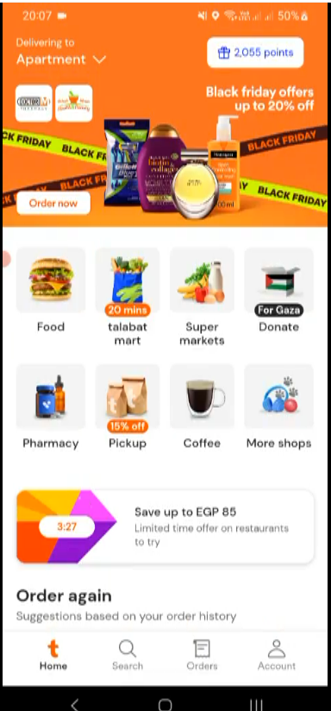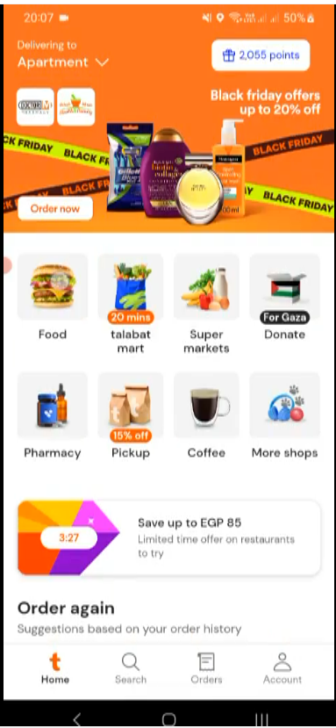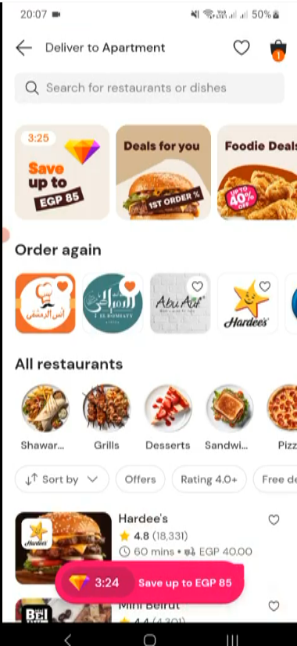

**Open Talabat APP**

Swipe filters Right

Tap on Food

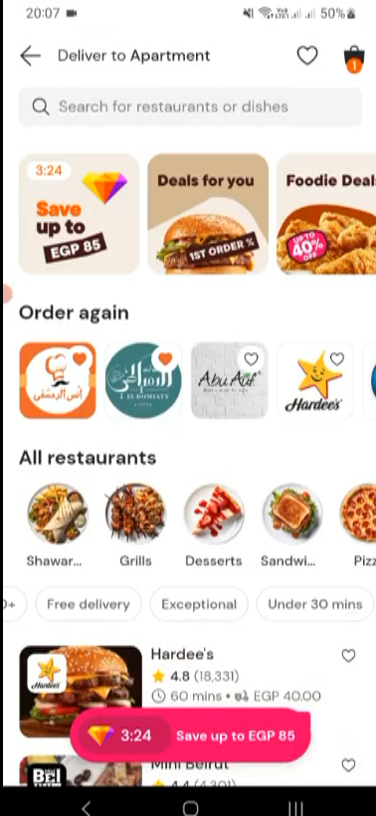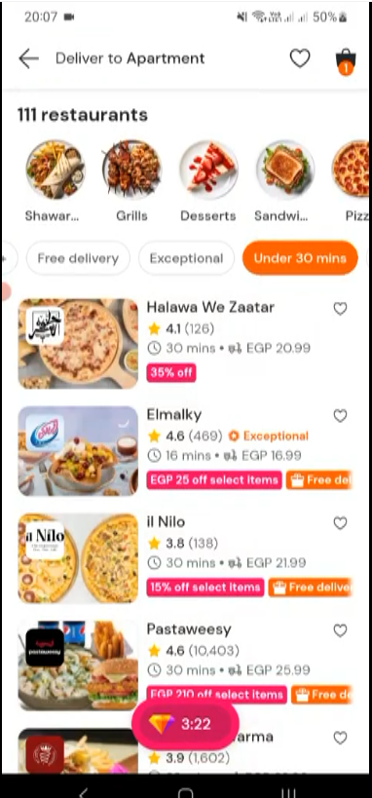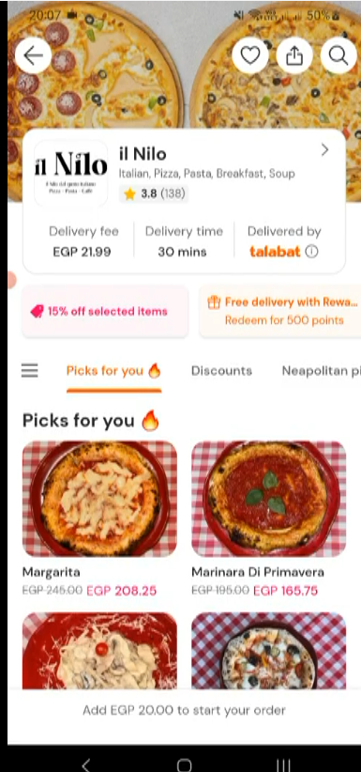

Tap On il Nilo

Tap on Under 3o mins